AWS Secrets Manager

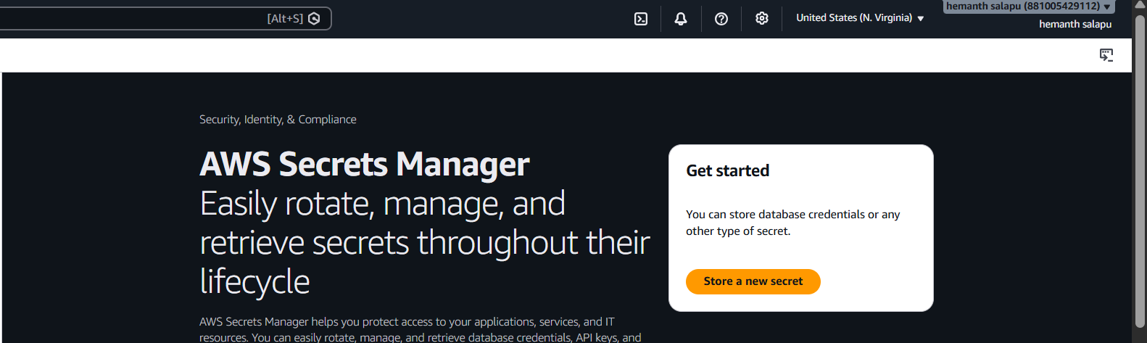
Choose secret type
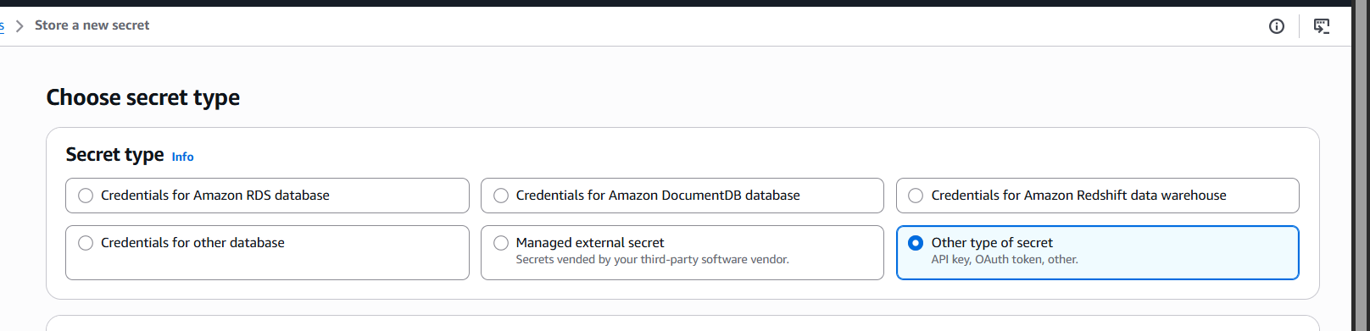

Configure secret name and description

Successfully created secrets

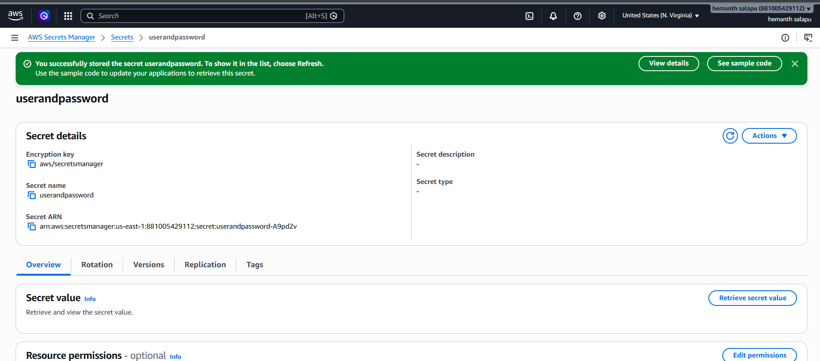
Verify we can see the username and password values

